Image | 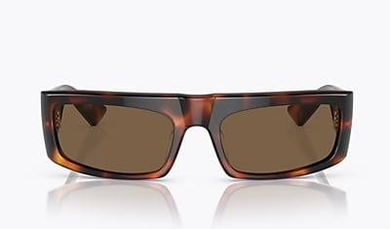
Brand | OLIVER PEOPLES
Model Name | 1979C
Price | RS 5170
PRODUCT DETAILS

